1. Biri cheksiz chegaralarga ega va ikkinchisi -1 va 1 oralig‘idagi chegaralarga ega. Bu tushuncha qaysi holatga mos?

a) Covariance vs Covariance Matrix  
b) Mean vs Correlation  
c) Z-score vs Min-Max  
d) Covariance vs Correlation

1. Unimodal va Bimodal asosan nimasi bilan ajralib turadi?

a) Ikkalasi ham Normal Distribution hisoblanadi va minimal qiymatlari har xil.  
b) Bimodal – multimodal hisoblanadi, Unimodal esa ikki maksimal qiymatga ega.  
c) Unimodal bir mode (maksimal) qiymatga ega, Bimodal esa ikkita mode ga ega.  
d) To‘g‘ri javob keltirilmagan.

1. Quyidagi kod qaysi formulaga tegishli?

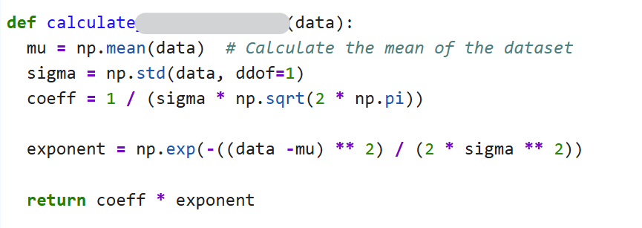

a) O‘rta arifmetikni hisoblash uchun  
b) Correlation  
c) Covariance  
d) Normal Distribution (Gaussian distribution)